NEUMERA
Longitudinal women’s health & AI coaching
Cycle & Fertility Module
The keystone Cycle Engine — functional architecture, screen layouts, and feature build notes
For dev-team and compliance review

Purpose of this document. This spec extends the existing Cycle Engine (Calendar, BBT, OPK, and the three intent “doors”) into the platform’s canonical reproductive-timeline service — the keystone the other four life-stage engines read from. It covers the two-customer architecture and internal contract, the three-door framing, the new and extended features (multi-signal fusion for forecasting and ovulation prediction, and hormone pattern analysis via upload), the AI-coach overlay, three reference screen layouts (the trying-to-conceive hero, the avoiding-pregnancy door, and hormone analysis), a regulatory flag for counsel, and a ready-to-run Cowork prompt. Screens shown are design references, not final production assets.
Stage framing. User-facing, this stage reads: turning the monthly cycle into a readable signal — decoding ovulation, hormones, and fertile windows so she can understand her body, plan conception, or simply know what’s coming.

0 · Data Privacy & Zero-Retention
Privacy is a first-class design principle across every Neumera module, not a compliance afterthought. The commitments below are inherited from Neumera’s core platform and privacy architecture and restated here so this document stands on its own for diligence review. They govern every feature in this specification.

Zero-retention AI
The AI keeps nothing; your account does. All AI inference runs on AWS Bedrock over private connectivity (VPC PrivateLink), under a signed Business Associate Agreement verified through AWS Artifact, with no retention of prompts or outputs by the model or the provider. The inference layer is stateless; durable value lives only in the user’s own longitudinal record. This is how zero-retention inference is reconciled with durable longitudinal storage — the record persists, the AI does not.

Trust domains and the de-identification gate
Data is separated into three trust domains with an isolated linkage store, so identity and health signal are never co-resident where the AI can see both. A fail-closed de-identification gate sits on any payload crossing from the identity zone to Bedrock: if the gate cannot strip identity, the request does not proceed.
Precision note. The platform’s privacy claims currently rest on pseudonymized status — not “de-identified” or “anonymized” — pending completion of the HIPAA §164.514(b)(1) Expert Determination scoping the AI-bound payload. Documentation and UI copy should use “pseudonymized” until that determination completes.

Regulatory posture
The FTC Health Breach Notification Rule is the primary regime at launch (no covered-entity or business-associate relationship, and no EU/UK presence at launch); HIPAA Security Rule practices, Washington’s My Health My Data Act, and GDPR readiness are maintained as the footprint expands, backed by an incident-response plan with breach-notification steps.

Commercial data boundary
The B2B provider-advertising layer targets geography and life-stage context only — never individual health signals. No module’s health data is used for ad targeting.

Highest-sensitivity data in this module
Cycle data, intent-door selection (trying to conceive / avoiding pregnancy / awareness), and uploaded hormone results — the platform’s single most sensitive category, given post-Dobbs legal exposure and the documented history of period-tracking data being subpoenaed. Intent-door and cycle data are treated as the highest-sensitivity tier, with front-of-house transparency about how they are protected (see Section 1).

1 · Architecture — the keystone engine with two customers
The most important design decision in this module is not a feature — it is recognizing that the Cycle Engine already has two customers, and only one of them is the user. Athlete reads cycle phase for its training overlay; Menopause reads cycle-gap changes for STRAW+10 staging; Pregnancy reads the cycle for EDD/dating. So this is the platform’s canonical reproductive-timeline service, and the highest-value move while extending it is to formalize a clean internal contract the other engines consume as an API.

The internal contract
Laravel owns and exposes an internal contract — current cycle day, phase, predicted ovulation, fertile-window range (with confidence), and cycle-length trend — that the other four engines read. Build the consumer surfaces on top of this contract, not intertwined with it. This is what makes “one longitudinal record” real rather than four apps sharing a database, and it is worth more to the platform than any single feature.

Building on the existing foundation
The current engine — Calendar, BBT tracking, OPK/LH input, and the three intent doors (trying to conceive, cycle awareness, avoiding pregnancy) with its tiered disclaimer copy — stays. This spec adds the internal contract, the multi-signal fusion model, and hormone-upload analysis around it.

The three doors reframe the same data
The underlying cycle model is identical across intents; the door changes framing, emphasis, and disclaimers only.
- Trying to conceive — fertile-window-forward, aspirational, “best days” emphasis; the safest door to be optimistic in.
- Cycle awareness — neutral body-literacy, no agenda, understanding patterns.
- Avoiding pregnancy — the razor’s edge. Natural Cycles is FDA-cleared as a Class II contraceptive device precisely because fertile-window prediction for pregnancy prevention is a regulated device function. Neumera is not cleared, so this door cannot function as, or imply, contraception. The design must actively resist being used as birth control: no safe/unsafe color coding, fertile days shown as neutral awareness, an unavoidable repeated “not birth control” statement, and an outbound route to a provider for real contraception.

Features — new and extended, with stack mapping
Confirmed stack: Laravel API core (owns the internal cycle contract) + Python/FastAPI internal ML microservice for the fusion/prediction math (async boundary, Python internal-only) + Flutter client. Ingestion via HealthKit / Health Connect (Flutter health plugin), Terra API for wearable temperature, plus manual Calendar/BBT/OPK and uploaded hormone results.
- Cycle forecasting, ovulation prediction, fertile-window detection — the technical core is multi-signal fusion in FastAPI. Prospective signals predict ahead (calendar history, LH/OPK surge, rising E3G); retrospective signals confirm and teach (BBT biphasic shift, PdG). The engine forecasts the window, confirms ovulation occurred, and tightens the user’s personal model each cycle (her real luteal length and variability — N-of-1). Deterministic/statistical and explainable, not a black-box model. Wearable temperature is graceful enrichment; the engine must work on manual Calendar + BBT + OPK alone.
- Honest uncertainty is the discipline here. Present fertile windows as ranges with confidence, never a single certain day; widen the window and say so for irregular cycles. No “day 14” false precision — personalized-and-humble beats precise-and-wrong.
- Hormone pattern analysis via upload — the user enters or photographs at-home hormone results (Mira, Inito, Proov, or lab values — E3G, LH, PdG, FSH), fused into the cycle picture: E3G approaching, LH surge imminent, PdG confirms ovulation occurred. Framed exactly like the Menopause logged-tests pattern — her uploaded data, plotted and interpreted, NOT a Neumera measurement, and confirmation/enrichment, not diagnosis. If photo upload is supported, OCR/parsing is a real build item and an accuracy/liability surface (a misread PdG is a false “you ovulated”).
- Cycle tracking — the existing Calendar/BBT/OPK feeds the fusion model and the internal contract.

Privacy — the highest-sensitivity tier in the platform
This is the most sensitive data Neumera holds. Post-Dobbs, menstrual and fertility data is legally and politically charged in the US — period-tracking data has been subpoenaed — and the intent-door signals (TTC, avoiding pregnancy) expose reproductive decisions directly. Specify intent-door and cycle data as the highest-sensitivity tier under the existing three-trust-domain architecture and Washington My Health My Data Act posture, and make the privacy stance a visible, front-of-house feature in this module. It is both an ethical obligation and a competitive wedge against incumbents who have mishandled exactly this.

2 · The AI coach — intent-aware Cycle overlay
The existing platform coach (patent’s layered base-prompt + life-stage-overlay orchestration, Bedrock, zero-retention, cost-routed, tier-metered) with a Cycle & Fertility overlay that reads the internal contract and adapts to the active door.
- Intent-aware. Encouraging and conception-focused in TTC; neutral and educational in awareness; and in the avoiding-pregnancy door it must never give contraceptive guidance and always route to a provider for birth control.
- Retrieval-grounded and off-quota. Cycle education is drawn from the EVP corpus; predictions and confirmations are coach-narrated automated summaries that do not count against her interaction cap.

3 · Screen layout — cycle hero (trying to conceive)
The fertile-window forecast, in the most aspirational door. Note the anti-false-precision framing.
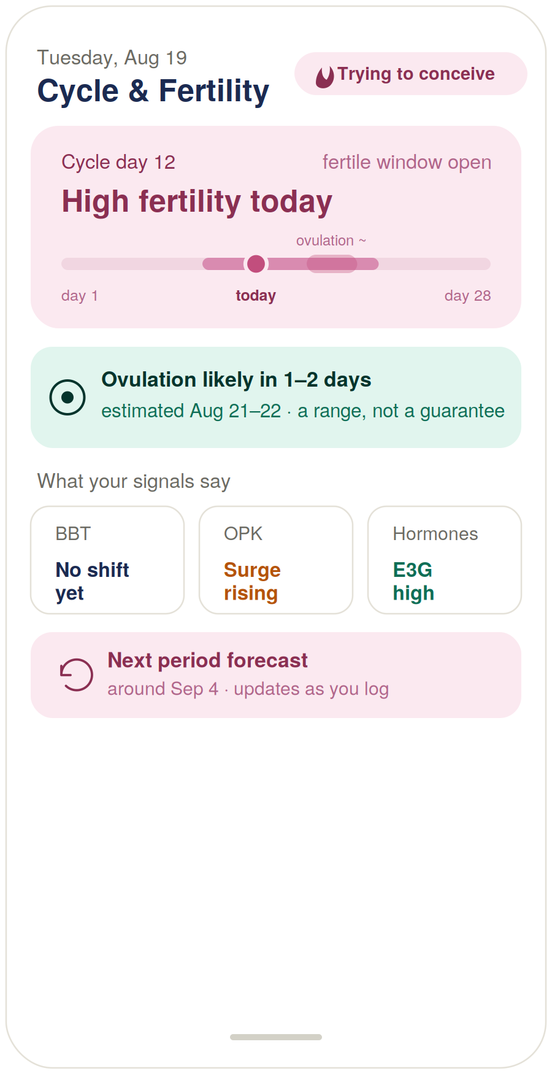
Figure 1 — Cycle hero, trying-to-conceive door (design reference).

Build notes
- The window is a range, ovulation a zone. Today’s position sits inside a shaded fertile range; ovulation is a soft zone, not a hard day.
- The prediction says the quiet part out loud. “Estimated Aug 21–22 · a range, not a guarantee” — honesty rendered on the glass.
- The signal chips show the fusion. BBT / OPK / Hormones make visible that the engine is triangulating, not guessing from the calendar alone.

4 · Screen layout — the avoiding-pregnancy door
Same engine, same data, framed to actively not be birth control. The highest-compliance-stakes screen in the module.
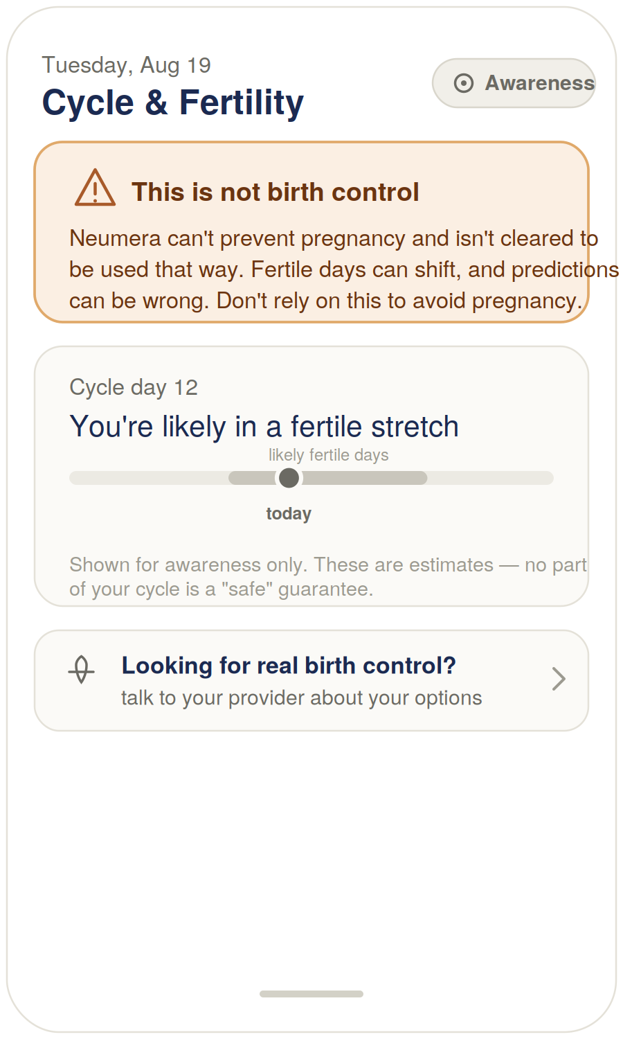
Figure 2 — Avoiding-pregnancy door (design reference).

Build notes
- The disclaimer leads. “This is not birth control” is the first thing on the screen, not a footer.
- Neutral coding, deliberately. Fertile days are rendered in grey — no green-safe / red-danger coding, which would imply contraceptive reliability. “No part of your cycle is a ‘safe’ guarantee.”
- It routes out, not deeper in. “Looking for real birth control? talk to your provider” — a product declining to be something it isn’t cleared to be.

5 · Screen layout — hormone pattern analysis (upload)
The new feature: uploaded hormone markers fused into the cycle picture, with PdG confirming ovulation.
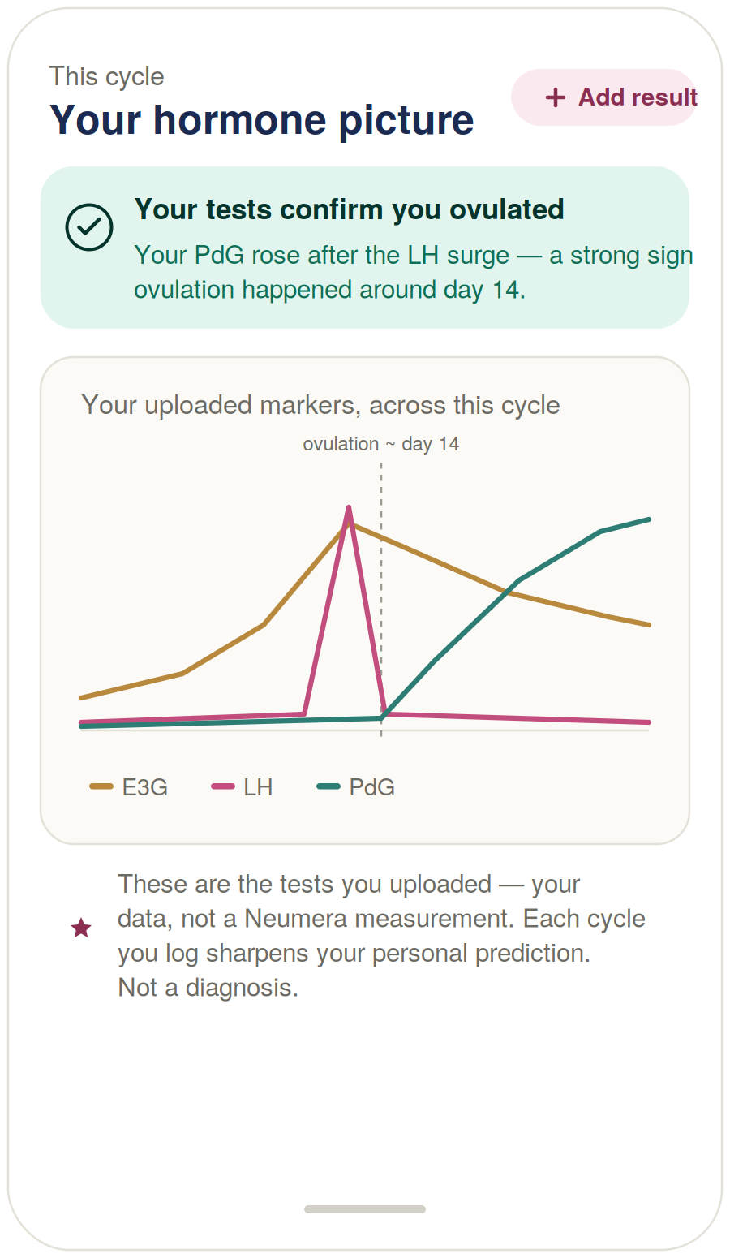
Figure 3 — Hormone pattern analysis via upload (design reference).

Build notes
- The three curves are the fusion made visible. E3G rising, the LH surge spiking, and PdG rising afterward to confirm ovulation actually happened — the marker most cycle apps can’t offer.
- The headline states the payoff. “Your tests confirm you ovulated” — confirmation, not prediction.
- The footer holds three disciplines at once. Her uploaded data (not a Neumera measurement), the N-of-1 learning loop (sharpens each cycle), and not-a-diagnosis — in two sentences.

6 · Regulatory flag — for counsel
As with the Pregnancy and Lifelong Thriving modules, one surface here sits near the medical-device boundary and should be on the diligence record before this module ships.
⚠ Software-as-a-Medical-Device (SaMD) review — the avoiding-pregnancy door
Issue. Fertile-window prediction used to prevent pregnancy is the exact function for which Natural Cycles was FDA-cleared as a Class II contraceptive device (De Novo, 2018). Neumera is not cleared. The avoiding-pregnancy door therefore approaches the Software-as-a-Medical-Device boundary and must not function as, or imply, contraception.
Why it matters here specifically. This is the one door where the same underlying prediction, framed as pregnancy prevention, crosses from wellness into a regulated device claim. The mitigation is not to weaken the feature but to hold the disclaimer-forward, non-contraceptive, route-to-provider design: unavoidable “not birth control” messaging, neutral (non-safe/unsafe) coding, and no reliance claims.
Recommended action. Have regulatory/privacy counsel review the avoiding-pregnancy door specifically before this module ships, including whether the current framing keeps it outside device territory, and pair it with the highest-sensitivity privacy treatment for intent-door data. This door (not the rest of the module) should gate launch on that review.

7 · Cowork build prompt (consolidated)
Drop this into Cowork to produce the full diligence-grade Cycle & Fertility module specification. The three screens above are referenced as Exhibits A–C, and the regulatory flag is carried into the compliance section.
Task
Produce a diligence-grade functional and technical specification document for the Cycle & Fertility life-stage module of the Neumera women’s health app, for our contract dev team and compliance reviewers. Match our established document system: navy and Sand Gold brand colors, Fraunces for headlines, Inter for body. First review our existing spec documents — especially the existing Cycle Engine / Section 7 fertility functional spec and its tiered “Avoiding Pregnancy” disclaimer copy (this module extends that foundation, it does not replace it) — plus the Athlete, Perimenopause/Menopause, Pregnancy & Postpartum, and Lifelong Thriving module specs, the health data ingestion architecture spec, the graceful-enrichment doc, and the AI coach patent specification.
Architecture — the keystone engine with two customers
Specify the Cycle Engine as the platform’s canonical reproductive-timeline service serving two customers: (1) the user, via three intent-framed consumer surfaces, and (2) the other life-stage engines, via a clean internal contract/API exposing current cycle day, phase, predicted ovulation, fertile-window range (with confidence), and cycle-length trend. Athlete consumes phase for its training overlay, Menopause consumes cycle-gap changes for STRAW+10 staging, and Pregnancy consumes the cycle for EDD/dating — specify these as internal consumers, and design the consumer surfaces on top of the contract, not intertwined with it. Laravel owns the contract; the FastAPI service does the fusion/prediction math.
Existing foundation to build on
Calendar, BBT tracking, and OPK/LH input already exist, as do three intent doors (trying to conceive, cycle awareness, avoiding pregnancy) with tiered disclaimer copy. Keep all of it; specify the extensions and the internal contract around it.
The three doors reframe the same data
The underlying cycle model is identical across intents; the door changes framing, emphasis, and disclaimers. TTC: fertile-window-forward, aspirational. Cycle awareness: neutral body-literacy. Avoiding pregnancy: NOT contraception — must actively resist being used as birth control (no safe/unsafe color coding, fertile days shown as neutral awareness, unavoidable repeated “not birth control” statement, outbound route to a provider for real contraception). Compliance reference: Natural Cycles is FDA-cleared as a Class II contraceptive device because fertile-window prediction for pregnancy prevention is a regulated device function; Neumera is not cleared.
Features — new and extended
Cycle forecasting, ovulation prediction, fertile-window detection — multi-signal fusion in FastAPI: prospective signals that predict (calendar history, LH/OPK surge, rising E3G) and retrospective signals that confirm and teach (BBT biphasic shift, PdG). Forecast the window, confirm ovulation occurred, tighten the user’s personal model each cycle (personalized luteal length and variability — N-of-1). Deterministic/statistical, explainable, not a black-box model. Wearable temperature is graceful enrichment; must work on manual Calendar + BBT + OPK alone. Present fertile windows as ranges with confidence, never a single certain day; widen and say so for irregular cycles — no “day 14” false precision. Hormone pattern analysis via upload — user enters or photographs at-home results (Mira, Inito, Proov, or lab values — E3G, LH, PdG, FSH), fused into the cycle picture (E3G approaching, LH surge imminent, PdG confirms ovulation occurred); framed like the Menopause logged-tests pattern — her uploaded data, not a Neumera measurement, confirmation not diagnosis; if photo upload is supported, specify OCR/parsing as a build item and accuracy/liability surface. Cycle tracking — existing Calendar/BBT/OPK feeds the fusion model and the internal contract.
Stack
Laravel API core (owns the internal cycle contract), internal Python/FastAPI ML microservice for fusion/prediction (async boundary, Python internal-only), Flutter client. Sources: HealthKit / Health Connect via the Flutter health plugin, Terra API for wearable temperature, plus manual Calendar/BBT/OPK and uploaded hormone results. AI on AWS Bedrock under the zero-retention pattern with the de-identification gate.
AI coach — intent-aware Cycle overlay
The existing platform coach with a Cycle & Fertility overlay that reads the internal contract and adapts to the active door: encouraging/conception-focused in TTC, neutral/educational in awareness, and in avoiding-pregnancy it must never give contraceptive guidance and always route to a provider for birth control. Cycle education retrieval-grounded in the EVP corpus; predictions/confirmations are coach-narrated automated summaries, off-quota.
Module-specific requirements
Privacy — highest-sensitivity tier: fertility and intent-door data is the most sensitive in the platform (post-Dobbs legal exposure; period data has been subpoenaed); specify intent-door and cycle data as the highest-sensitivity tier under the existing three-trust-domain architecture and Washington My Health My Data Act posture, and make the privacy stance a visible front-of-house feature. Honest uncertainty — ranges and confidence over false precision everywhere predictions surface. Compliance framing — tracking, forecasting, and awareness are informational wellness; the avoiding-pregnancy door is explicitly not contraception; hormone analysis is confirmation, not diagnosis. Phased build: internal contract + fusion prediction + the three doors first; photo-OCR hormone upload and wearable temperature as enrichment.
Regulatory flag to carry into the compliance section
Flag that the avoiding-pregnancy door approaches the FDA’s Software-as-a-Medical-Device boundary because fertile-window prediction for pregnancy prevention is the exact function Natural Cycles was cleared for; require regulatory/privacy counsel review before launch. Frame the mitigation as the disclaimer-forward, non-contraceptive, route-to-provider design — not weakening the feature. State that this door (not the rest of the module) should gate launch on that review, paired with the highest-sensitivity privacy treatment for intent-door data.
Reference exhibits to include and build against
Exhibit A — Cycle hero, trying-to-conceive door (Figure 1): fertile window as a shaded range with today’s position and ovulation as a soft zone; a fertility status line; ovulation prediction stated as a range (“a range, not a guarantee”); BBT/OPK/hormone signal chips showing the multi-signal fusion; next-period forecast. Rose palette.
Exhibit B — Avoiding-pregnancy door (Figure 2): leads with an unavoidable “this is not birth control” banner; fertile days rendered in neutral grey (no safe/unsafe coding) as “awareness only”; explicit “no part of your cycle is a safe guarantee”; an outbound “looking for real birth control? talk to your provider” route.
Exhibit C — Hormone pattern analysis via upload (Figure 3): uploaded E3G/LH/PdG markers fused across the cycle with PdG confirming ovulation; a “your tests confirm you ovulated” headline; a footer stating this is the user’s uploaded data (not a Neumera measurement), sharpens the personal prediction each cycle, and is not a diagnosis.

Practical note. Cowork cannot ingest the three rendered screens as images from the chat directly — either describe Exhibits A–C in the prompt (as done above) or attach Figures 1–3 from this document to the Cowork session as visual references.

